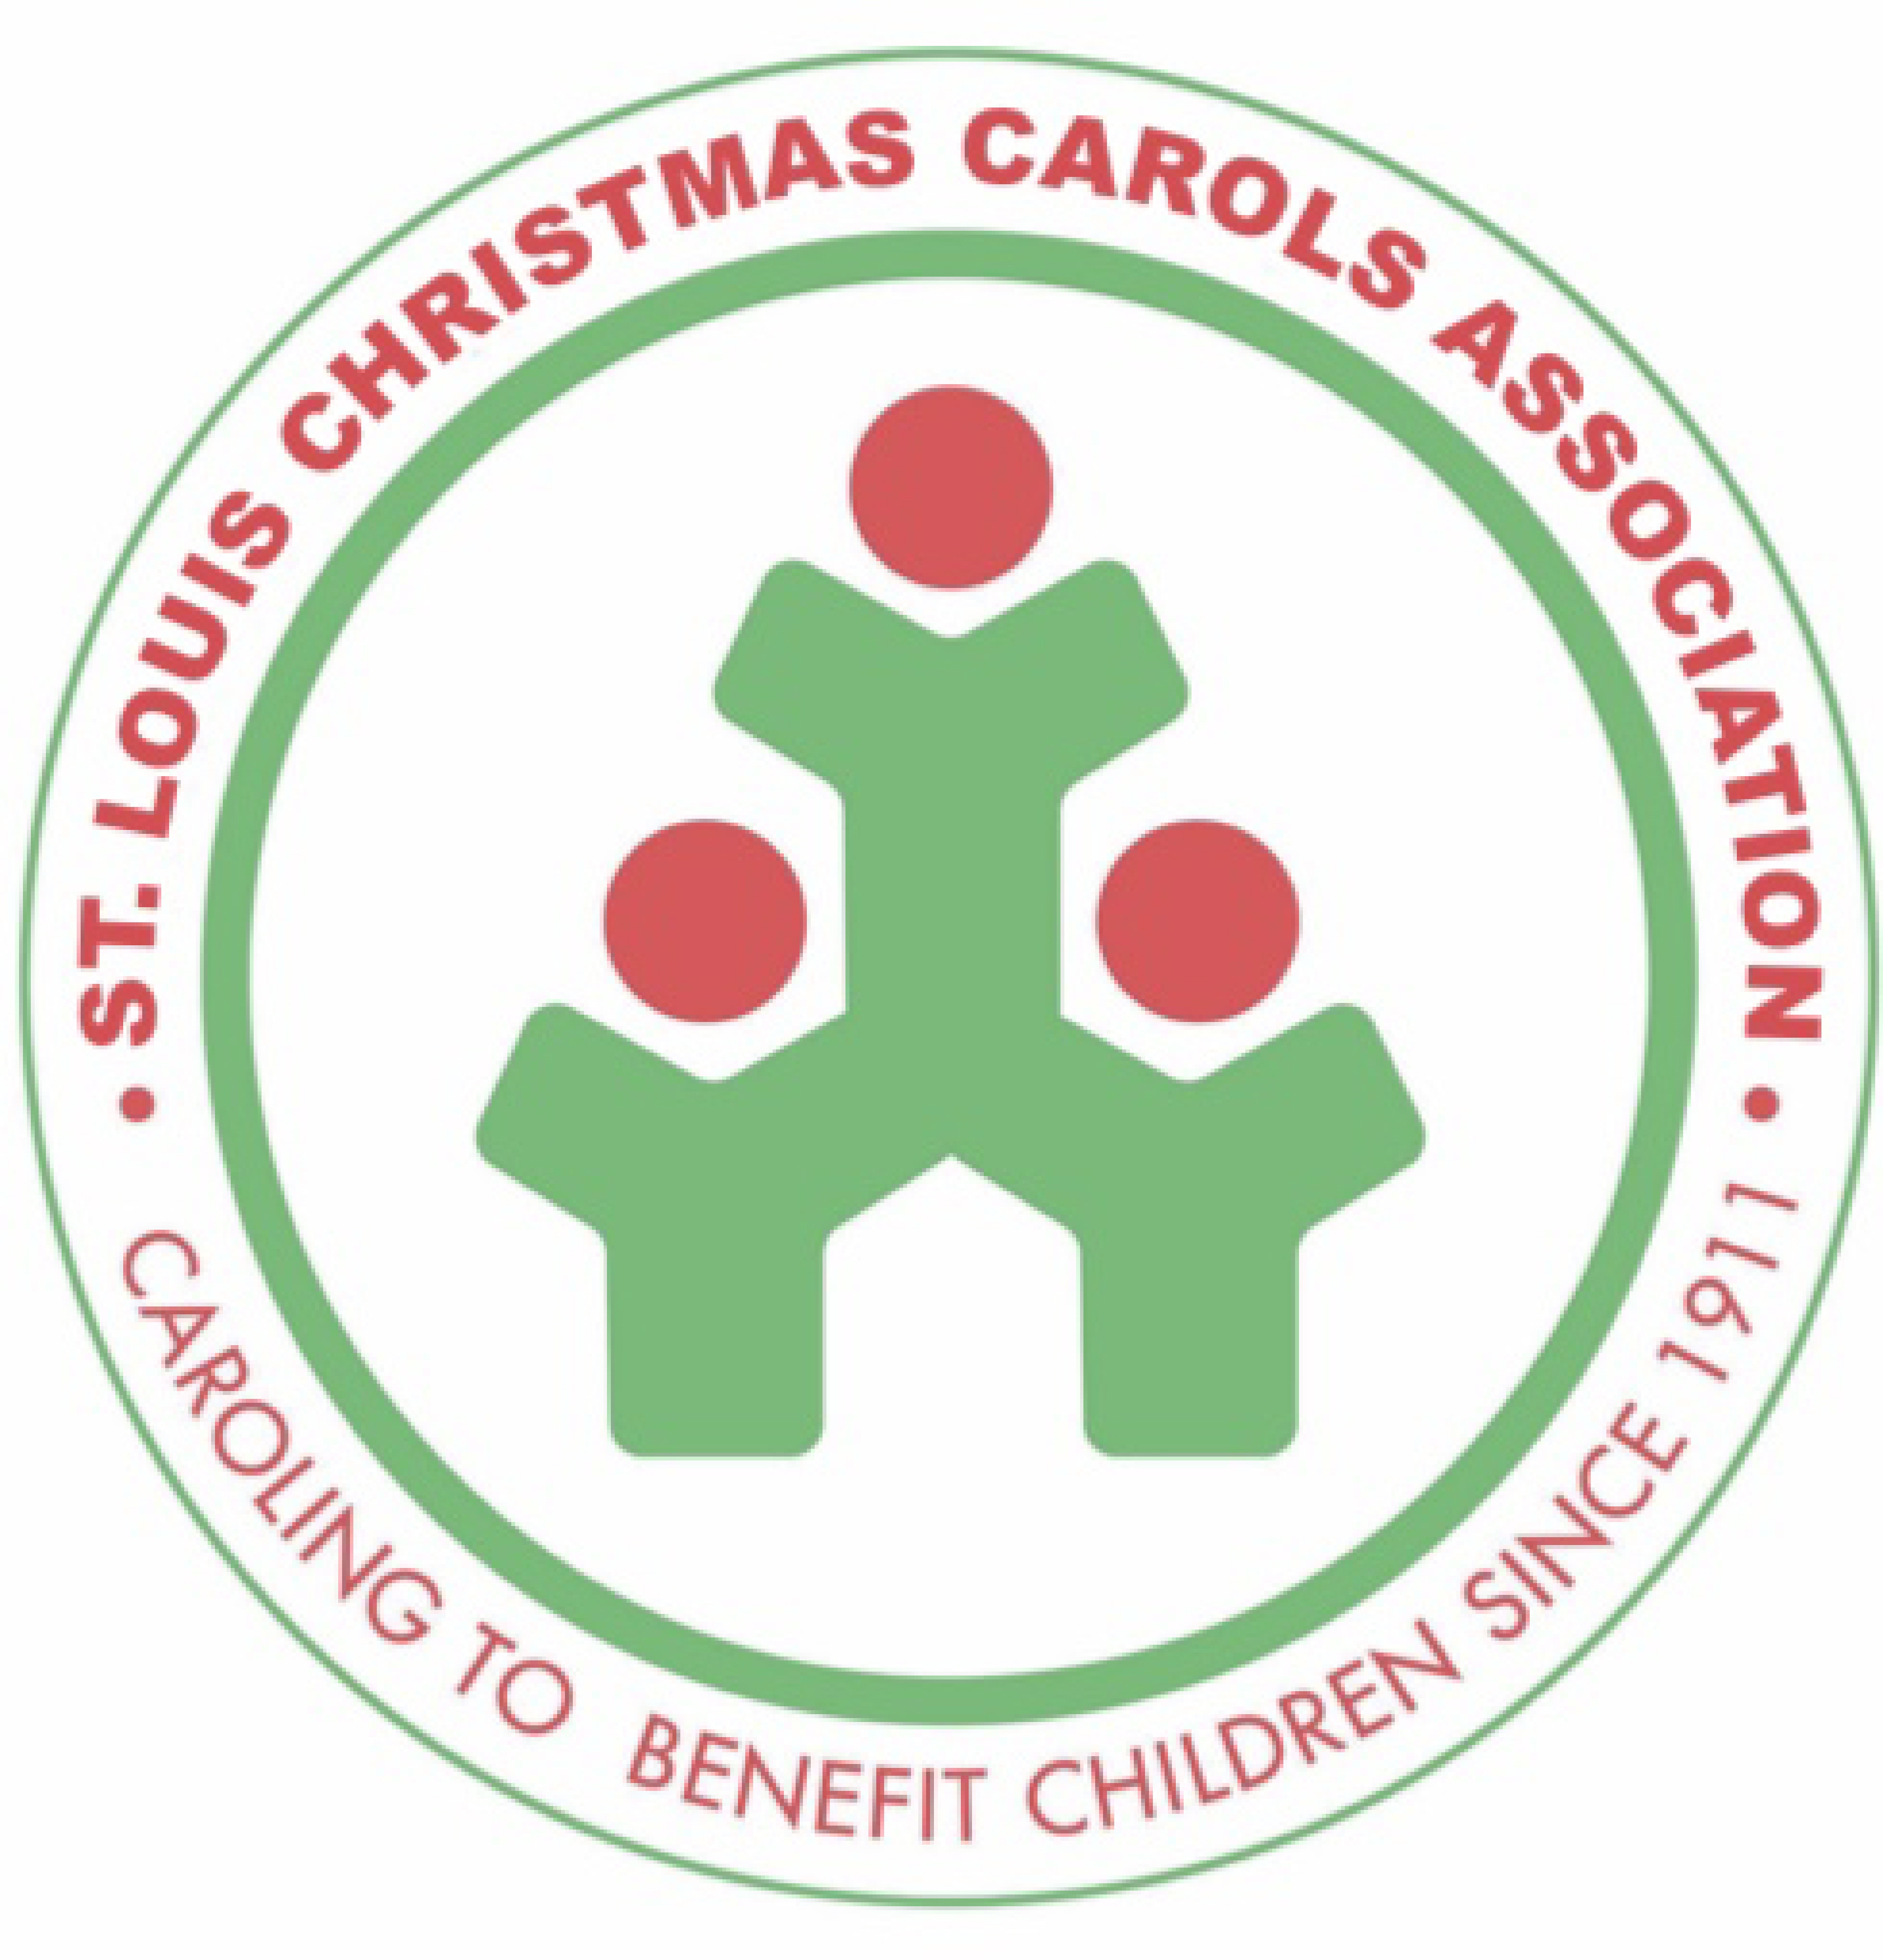Date____________________

St. Louis Christmas Carols Association
Agency Report 2020

Use of Allocated Funds/Request for New Funds

GENERAL INFORMATION

Agency Name: ________________________________________ Address: _______________________________________ City/State: ___________________________ Zip: ______________ Phone: (______)______________________

Contact Name/Title: ________________________________ Email: ____________________________________

Is the Agency a 501(c)(3) nonprofit organization? ________Yes ________No

Agency Mission: _______________________________________________________________________________________________
_________________________________________________________________________________________________________________
_________________________________________________________________________________________________________________

Does your agency have a relationship with a member of the St. Louis Christmas Carols Association? ________

If so, who? _____________________________________________________________________________________
Our allocations are dependent on caroling participation/collections.
We urge funded agencies to help us help them by forming caroling groups with family, friends, staff and/or clients.
*************Priority is given to caroling agencies when determining allocation levels.**************

Does your agency currently participate in caroling for the St. Louis Christmas Carols Association?__________

Would members/staff/family of your agency be interested in forming a caroling group this year? ____________

Please provide a name/email for a group leader. _____________________________________________________
We will follow up in October with caroling suggestions and support.

USE OF FUNDS

Amount received for 2019 caroling season: _______ Number of children served w/StLCCA funds:__________ Funds were used for: ___________________________________________________________________________________________
_________________________________________________________________________________________________________________
_________________________________________________________________________________________________________________
***Please attach receipts (for purchases) and/or accounting of how funds were spent.***

Amount requested for 2020 caroling season: ______ Number of children to be served w/StLCCA funds: ______ Funds to be used for: ______Basic Needs ______Educational Programs

How funds will be used: (please include how use complies with “Conditions Governing Use of Funds”) _________________________________________________________________________________________________________________

_________________________________________________________________________________________________________________
_________________________________________________________________________________________________________________
_________________________________________________________________________________________________________________
Please return this form no later than SEPTEMBER 30, 2020

By USPS Mail to: St. Louis Christmas Carols Association, 7425 Forsyth Blvd Suite 353, St. Louis, MO 63105
By email to: stlcca@att.net (also found on our website stlchristmascarols.org/about-us – scroll down to Where the Money Goes

