Culver City Caroling, 2013
We had about a dozen singers for the first annual caroling party in Culver City. No one in the neighborhood knew we were coming, so we had a few confused neighbors at first.

One neighbor tentatively opened the door and said, "We're Lutheran, so we're good. And we're in the middle of a movie, so...."

But we pushed through the awkwardness of figuring out how to unobtrusively ring people's doorbells at night in Los Angeles and had some magical moments. One woman did some interpretive dancing on her porch as we sang. A young teenager was by herself at home for the evening and looked simultaneously comforted by our presence and uncomfortable not knowing where to stand or what to do. Children peered through curtains and from behind parents to see carolers for the first time.

We happened upon a family down the street who were having their own party. They gestured to us to come closer, so we moved up the driveway. Then they kept gesturing and invited us inside the house. So our group of carolers and their group of 20 or so family members crammed into their small living room as we sang a medley of carols. There were grandmas and babies and everyone in between. They offered us to partake in their holiday smorgasbord, but we had our own refreshments waiting, so we went on our way. As they closed the door, they cranked up the music, and the grandmas started dancing around the living room. One member of our group looked at her dad and said, "Our family is so boring."

A few houses later, we met Enid. She's 95 years old and has lived on the street for 58 years. She stumbled out to the driveway in her pink bathrobe, nearly losing her balance on multiple occasions. She was so pleased to have us and started belting out "Go Tell it on the Mountain" with us. We were so touched by Enid's vigor and enthusiasm for life we stayed and chatted as long as she could manage.

Then we crossed the street where the family asked, "Did you sing for Enid? She would really love this!” Apparently, Enid is something of a celebrity on the south end of Tilden Avenue.

We all returned for mini-cheesecakes and warm beverages knowing we'd experienced something remarkable and unexpected, even magical.
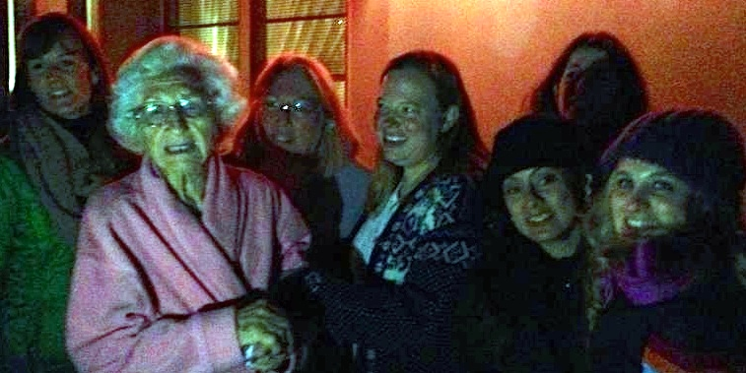

Ann and her group with Enid.

